**Creating tables:**

**ORDERS Table**

SQL> create table orders(id number(2),product_id number(2),buyers_id number(2),order_volume number(2), order_total_cost number(5,2));

Table created.

**BUYERS Table**

SQL> create table buyers(buyers_id number(1),name varchar(20),Primary Key(buyers_id));

Table created.

**INSERTING values into tables:**

1: insert into orders values(1,2,3,10,100.00);

2:insert into buyers values(1,'John');

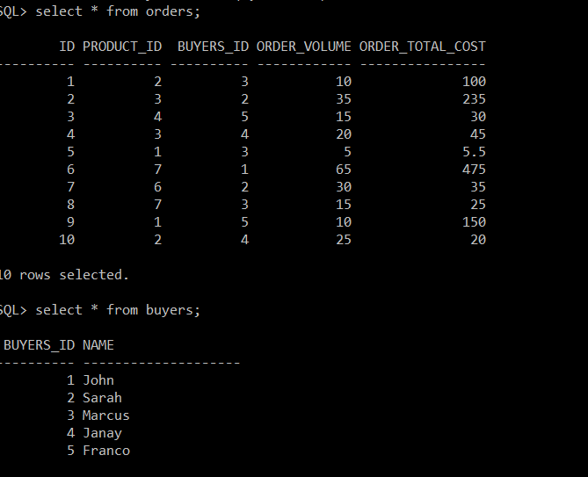

**QUERY**

**select b.name as NAME,count(*) as Num_orders,sum(o.order_volume) as total_volume, sum(o.order_total_cost)as total_spent**

**2  from orders o**

**3  inner join buyers b on o.buyers_id=b.buyers_id**

**4  group by o.buyers_id,b.name**

**5  order by o.buyers_id;**

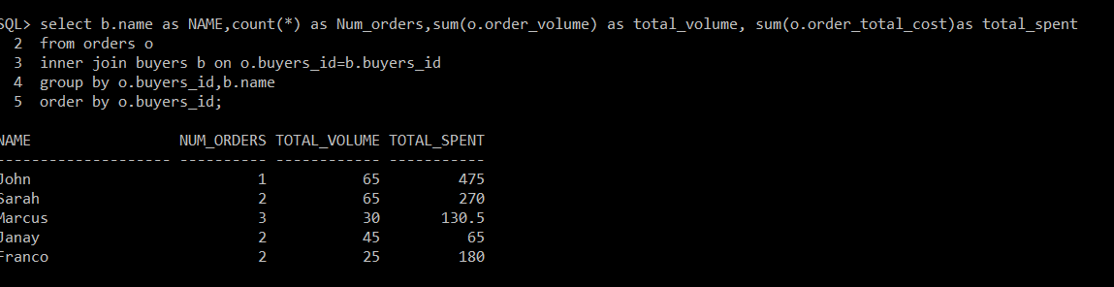

**4. For web pages to change the values of email id we need to create one more script that searches all the html files the script can be in the following way.**

**Loop:**

**1. Open the html file**

**2.If the file contains the email id =**[**Support@amazon.com**](mailto:Support@amazon.com)

**3. Replace the email id as email id=** [**Contact@amazon.com**](mailto:Contact@amazon.com)

**4. Close the file**